Coupled Ionic-Electronic Equivalent Circuit to Describe Asymmetric Rise and Decay of Photovoltage Profile in Perovskite Solar Cells
Firouzeh Ebadiª, MasoudAryanpour^{a,b}, Raheleh Mohammadpour^{*, a}, Nima Taghavinia^{*, a,c}
ª Institute for Nanoscience and Nanotechnology, Sharif University of Technology, Tehran 14588, Iran
^{b} Department of Mechanics, Sharif University of Technology, Tehran 14588, Iran
^{c} Department of Physics, Sharif University of Technology, Tehran 14588, Iran

Table S1.Photovoltage rise and decay parameters related to solar cells with different absorber materials. Information are extracted from the curves of Figure 2.
Absorber | Temperature (K) | photovoltage rise | (ΔV_{R1})Initial Fast Voltage rise after 50 ms (mV) | (τ_{r}) Time interval for full rise (S) | (ΔV_{R2}) Slow oltage rise (mV) | Photovoltagedecay | (ΔV_{D1})Initial Fast Voltage decay after 50 ms (mV) | (τ_{d}) Time interval for full decay (S) | (ΔV_{D2})Slow voltage decay (mV)
MAPbI | 278 |  | 709 | 30 | 199 |  | 722 | 16 | 196
 | 283 |  | 698 | 24.5 | 197 |  | 656 | 13.1 | 214
 | 288 |  | 664 | 23.9 | 206 |  | 652 | 12.1 | 193
 | 298 |  | 655 | 19.3 | 198 |  | 630 | 8 | 197
 | 308 |  | 637 | 14.1 | 184 |  | 593 | 5.4 | 201
 | 316 |  | 620 | 8.5 | 189 |  | 586 | 6.8 | 195
 | 323 |  | 617 | 6.5 | 176 |  | 563 | 4.2 | 202
MAPbBrI | 278 | photovoltage rise | 865 | 15 | 254 | Photovoltagedecay | 369 | 390 | 726
 | 283 |  | 878 | 10.8 | 234 |  | 346 | 264 | 741
 | 288 |  | 867 | 9.7 | 239 |  | 345 | 184 | 736
 | 293 |  | 859 | 8.8 | 242 |  | 336 | 144 | 731
 | 298 |  | 854 | 6.6 | 235 |  | 340 | 91 | 723
 | 303 |  | 863 | 4.4 | 217 |  | 333 | 76 | 720
 | 308 |  | 862 | 4 | 208 |  | 331 | 53 | 712
 | 313 |  | 852 | 3.5 | 210 |  | 330 | 40 | 705
 | 318 |  | 869 | 2.6 | 184 |  | 332 | 30 | 694
CsFAMAPbBrI | 276 | photovoltage rise | 870 | 103 | 255 | Photovoltagedecay | 272 | 353 | 829
 | 283 |  | 885 | 94 | 242 |  | 266 | 250 | 837
 | 289 |  | 887 | 78 | 235 |  | 247 | 200 | 850
 | 293 |  | 880 | 50 | 220 |  | 277 | 134 | 798
 | 298 |  | 885 | 42 | 222 |  | 262 | 109 | 819
 | 303 |  | 889 | 32 | 212 |  | 247 | 92 | 823
 | 308 |  | 869 | 24 | 224 |  | 221 | 68 | 845

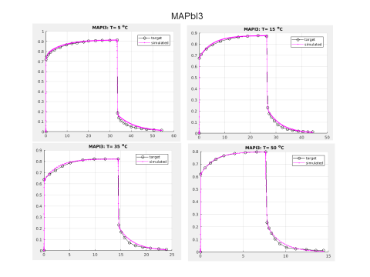
Figures S1: Fitted curves for photo-voltage rise and decay profiles of MAPbI3 were fitted through the equivalent circuit of Figure 3a
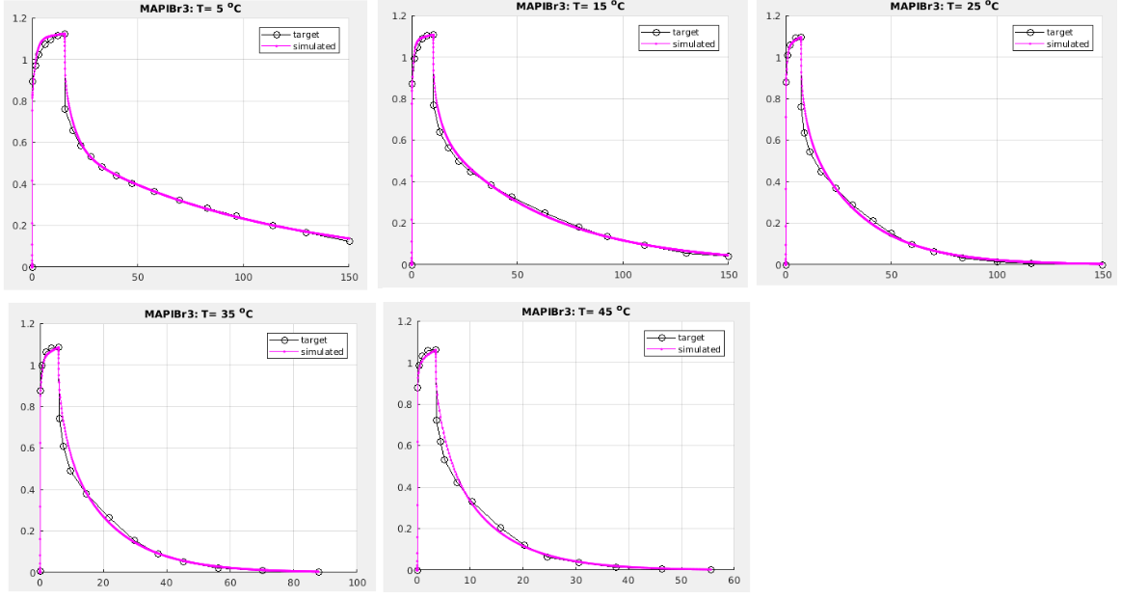
Figures S2: Fitted curves for photo-voltage rise and decay profiles of MAPb(I,Br)₃ were fitted through the equivalent circuit of Figure 3a

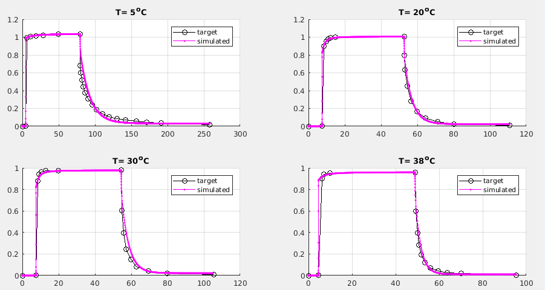
Figures S2: Fitted curves for photo-voltage rise and decay profiles of CsFAMAPb(I,Br)₃ were fitted through the equivalent circuit of Figure 3a

